To add workspace to remote repo

git init

git add .

git commit

git config –global //To avoid error if occurs after git commit

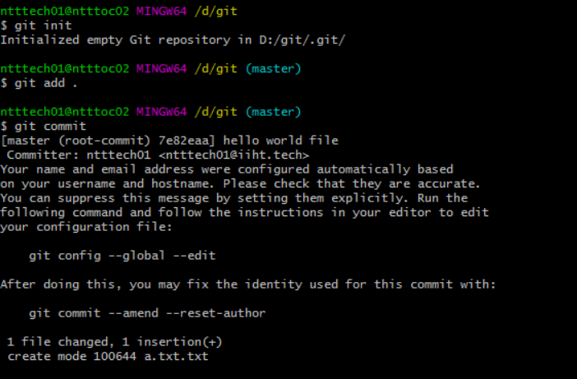

2.

$ git config --global user.name = Vkvipul91

$ git config --global user.email = Vk.vipul91@gmail.com

Login to github and create repo by name “practiceRepo”

$ git remote add origin [git@github.com:Vkvipul91/practiceRepo.git](mailto:git@github.com:Vkvipul91/practiceRepo.git) //FOR SSH

git push -u origin master

The authenticity of host 'github.com (13.234.176.102)' can't be established.

RSA key fingerprint is SHA256:nThbg6kXUpJWGl7E1IGOCspRomTxdCARLviKw6E5SY8.

Are you sure you want to continue connecting (yes/no/[fingerprint])? Yes

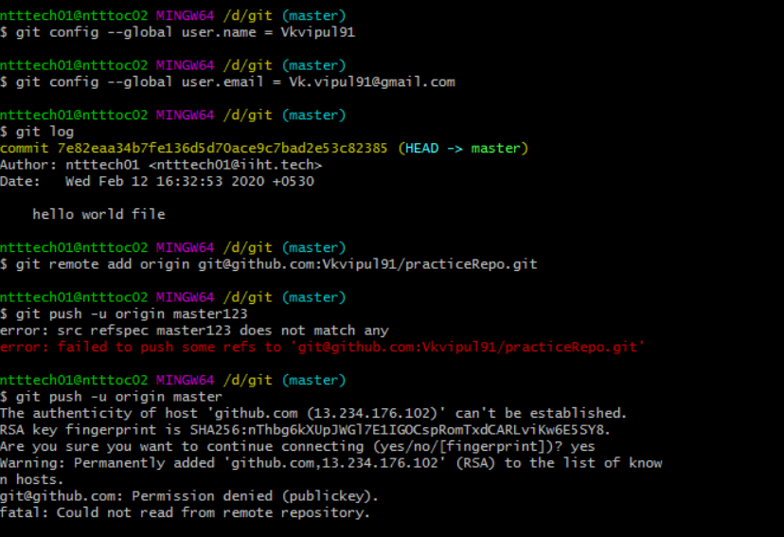

3. Changing SSH to HTTPS

git remote set-url origin <https://github.com/Vkvipul91/practiceRepo.git>

git push -u origin master

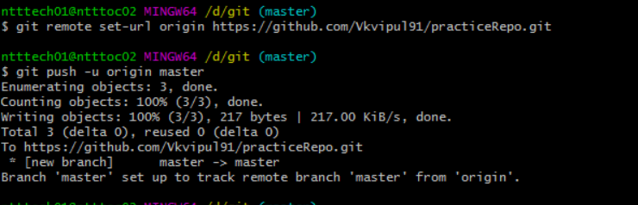

Create a new branch from master

1. Git checkout –b “feature/newBranch” (it will create a branch from local master)

Do the work

1. Vi a.txt
2. Git status

Then add/commit/push your changes

1. Git add .
2. Git commit –m “message”
3. Git push (This will push code from workspace to local branch on which you are working)

Create the pull request & merge the code to base i.e “master” and compare branch shoulf be the branch

1. Login to Github
2. Create new Pull Request
3. Base : Master
4. Compare Branch : Local Branch

Then checkout to local master and take pull from remote master

1. Git checkout master (pointing to local master)
2. Take the latest code from Remote master

Git pull origin master